**REPORT**

DATA INTENSIVE COMPUTING – CSE 487/587

SPRING 2016 - PROJECT 2 - PART 2

AUTHOR: SAURAV MOHAPATRA (50101106)

sauravmo@buffalo.edu

AUTHOR: SUDHARCHITH SONTY (50169912)

sudharch@buffalo.edu

**SCRIPT 1:**

**Author: Saurav Mohapatra**

MR -> Extract Enrollment/Capacity for each hall, every sem.

**EXPECTED OUTPUT:**

* NSC SPRING 2014 345 420
* BALDY SPRING 2014 333 400

**ACTUAL OUTPUT:**

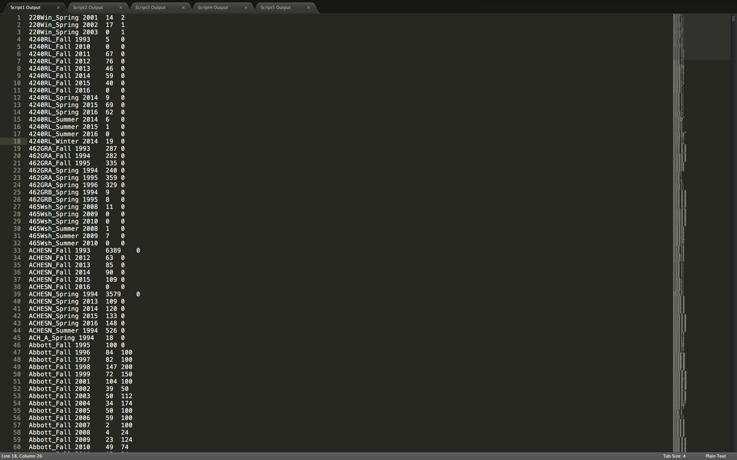

This MR Script is used to answer the below questions:

* Are halls being underutilized immensely?

We can clearly see from our data that some halls are. For example, we can see that Cooke hall is usually underutilized (~50%) every semester since 1993.

Example: Cooke_Spring 2015 4701 8801

Cooke_Spring 2016 5472 9845

* Which halls are being used up to capacity?

No halls are being used up to capacity from examining our data. Some halls are close to capacity roughly but still not full (for example Bell Hall).

Example: Bell_Spring 2015 1557 2117

Bell_Spring 2016 1989 2634

* Which particular halls have the most leftover space?

Examining our data, we can see that, the DeifenDorf Hall in the south campus, has always been less than Half full.

Example: Dfn_Fall 1993 8746 13108

Dfn_Fall 1994 8919 20243

Dfn_Fall 1995 8397 15827

Dfn_Fall 1996 9273 18654

Dfn_Fall 1997 4525 12007

Dfn_Fall 1998 5428 17100

Dfn_Fall 1999 5930 14185

Dfn_Fall 2000 7098 17968

Dfn_Fall 2001 6262 15968

Dfn_Fall 2002 5642 12492

Dfn_Fall 2003 6003 15514

Dfn_Fall 2004 6447 18285

Dfn_Fall 2005 7500 20779

Dfn_Fall 2006 7576 19012

Dfn_Fall 2007 8124 20478

Dfn_Fall 2008 9345 24448

Dfn_Fall 2009 9083 24676

Dfn_Fall 2010 11397 32635

Dfn_Fall 2011 10816 31227

Dfn_Fall 2012 10038 25472

Dfn_Fall 2013 9636 25597

Dfn_Fall 2014 9306 24473

Dfn_Fall 2015 9379 24842

Dfn_Fall 2014 9306 24473

Dfn_Fall 2015 9379 24842

* Which hall had the largest enrollment (number of students) last semester?

Based on our data we can see that NSC (Natural Sciences Complex) had the highest number of students at 22,265 last semester (Fall 2015).

**SCRIPT 2:**

**Author: Sudharchith Sonty**

MR -> Extract Enrollment/Capacity for each semester every year

**EXPECTED OUTPUT:**

* SPRING 2014 3456 3600
* FALL 2014 3000 3600

**ACTUAL OUTPUT:**

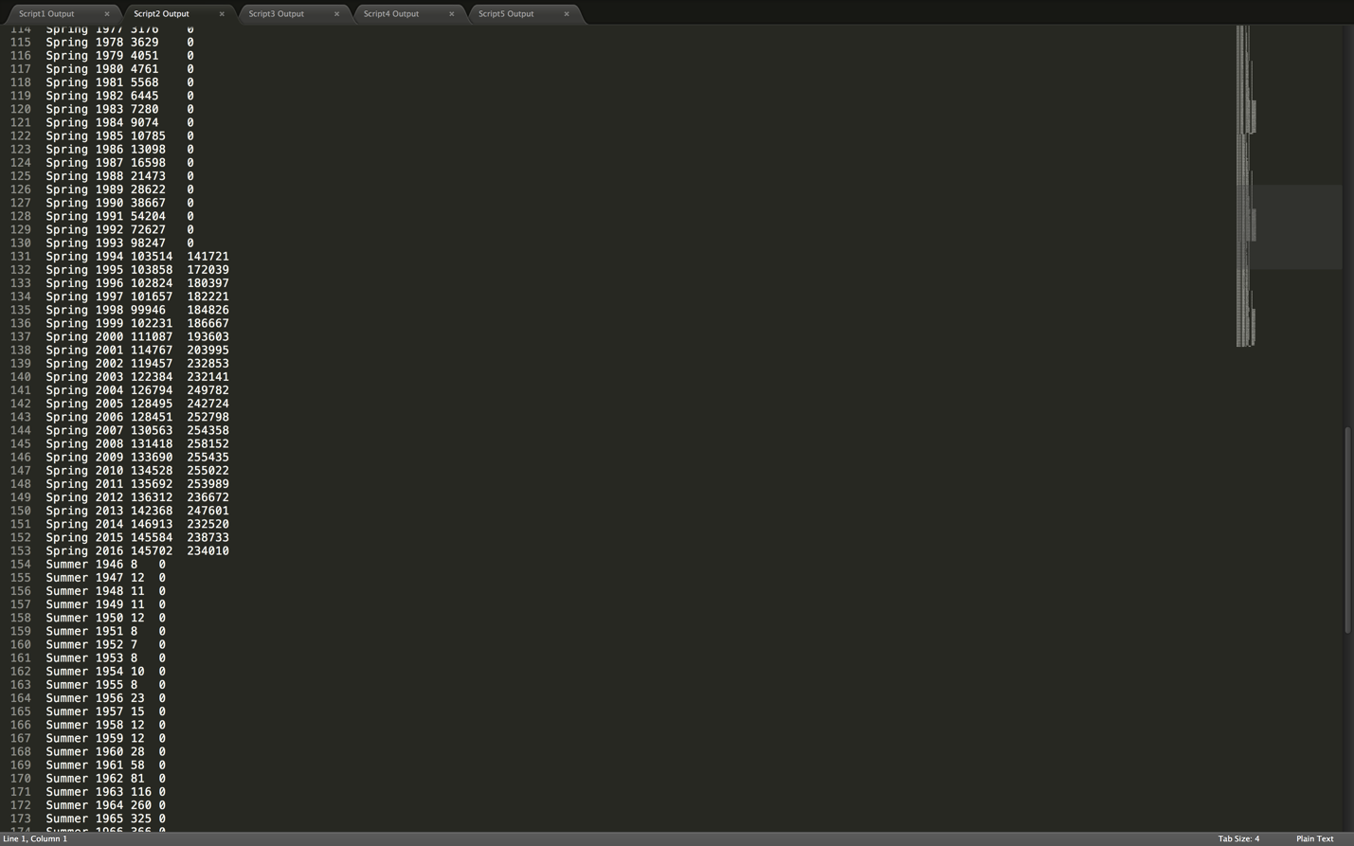

This MR Script is used to answer the below questions:

* Which semester do students generally enroll in?

Looking at the data, we can clearly see that Fall has way more enrollment that the spring semester. For example, fall 2015 recorded an enrollment of 162,267, while Spring 2016 saw an enrollment of 145,702. This trend holds for data since 1993.

Example: Spring 2016 145702 234010

Fall 2015 162267 268840

* Do we see an upward or downward trend with that semester in the last few years?

Apart from a few stagnant periods (with non-significant +/-), the enrollment has increased in general over the last couple of years.

Example: Spring 2013 142368 247601

Spring 2014 146913 232520

Spring 2015 145584 238733

Spring 2016 145702 234010

* Should UB increase more intake in Fall or Spring semesters?

It currently looks like UB has more students enrolled in the Fall semester every year than the spring. UB can definitely look more into spring recruitment by reaching out to transfer students for example.

* Are halls underutilized more in a specific semester?

Given our data, we can see that halls are more underutilized during the spring semester because of lower enrollments compared to the Fall semester.

**SCRIPT 3:**

**Author: Saurav Mohapatra**

MR -> Extract Enrollment/Department for each year

**EXPECTED OUTPUT**

* MTH 2014 5764
* BIO 2014 4444

**ACTUAL OUTPUT:**

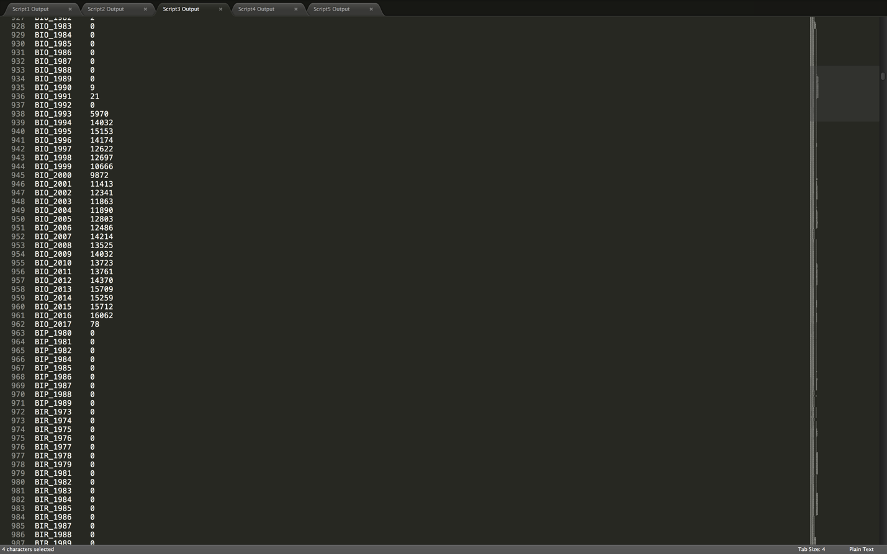

This MR Script is used to answer the below questions:

* Which department had the largest enrollment last semester?

The Chemistry department at UB has the highest enrollment out of all departments. We can simply compare the enrollments under Fall 2015 for each department. Chemistry had 10854 enrollments in their courses out of a capacity of 13845.

* Which department had the least enrollment last semester?

The ENS (0/14), AP (0/62) & MD (0/250) departments had the lowest enrollment of 0 students according to the data.

* What is the nature of enrollment in the Arts/Architecture Department when compared to last year?

Spring 2015 ARC 831/3978

Spring 2015 ART 802/1476

Spring 2016 ARC 2147/4897

Spring 2016 ART 814/1581

Looking at the above numbers, we can clearly see that the Architecture department has a substantial increase in enrollment from last year, while the arts department has a significantly lower amount of increase.

* Which department had the largest increase in enrollment over the last decade?

It is our own CSE department which has seen the largest increase in enrollment over the last decade at UB. In 2006, our enrollment was at 24,710. Now, in 2016, it is 29,546 (not including Fall 2016 enrollments).

* Which departments have seen a decrease in enrollment from last year?

Some departments like the DNS, ELEC, EMP, END, ESL have seen some decrease.

ESL_2015 1979 END_2015 2116

ESL_2016 1565 END_2016 1572

**SCRIPT 4:**

**Author: Sudharchith Sonty**

MR -> Extract enrollment/capacity for each department for every semester/year

**EXPECTED OUTPUT:**

* SPRING 2014 ENG 134/600
* FALL 2014 ENG 565/600

**ACTUAL OUTPUT**

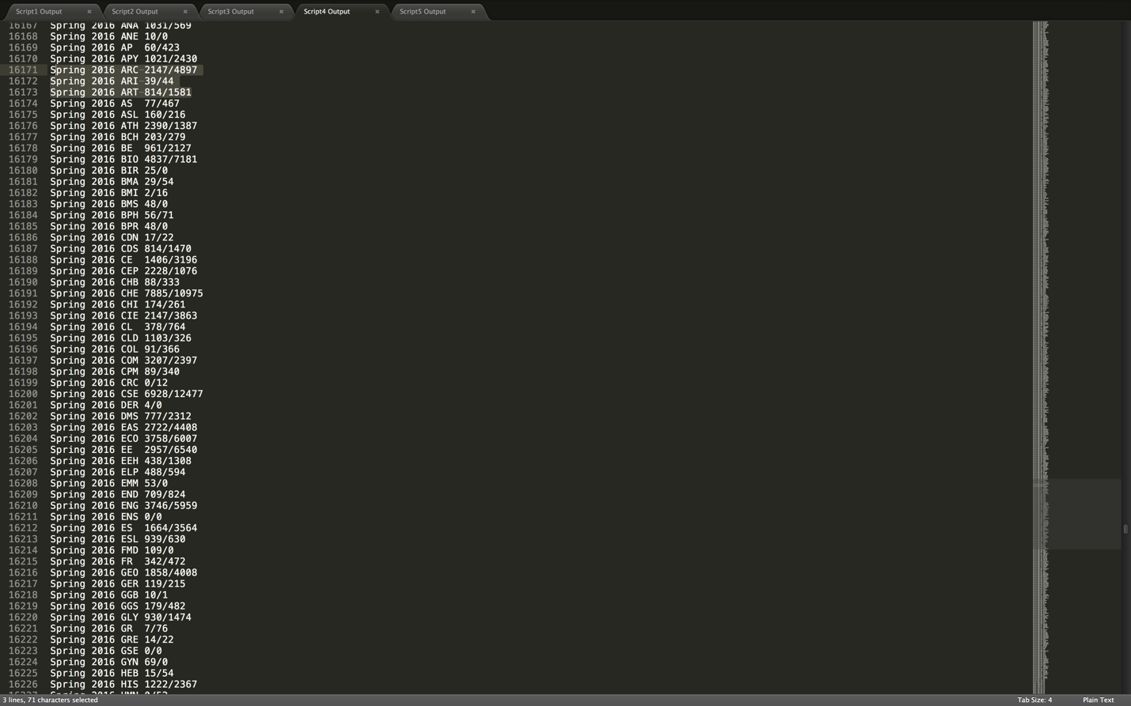

This MR Script is used to answer the below questions:

* Has the number of departments increased/decreased over the last year?

Yes. The number of departments has increased by 2: 174 in Spring 2015 as opposed to the 176 in Spring 2016

* Were there any departments that had full enrollment last semester?

Looking at the Fall 2015 departments last year, we can say that the closest was the MGO Department (1307/1274), which could probably mean a slight over enrollment. But otherwise, no department had a full enrollment.

* Which department has the highest capacity last semester?

The Chemistry department had the highest capacity last semester.

Fall 2015 CHE 10854/13845

* How much has the CSE Department increased in student enrollment over the past decade?

In 2005, the capacity of the CSE Department was 7986 and the capacity of the CSE Department capacity in 2015 is 13942 which is a 74.5% increase.

**SCRIPT 5:**

**Author: Saurav Mohapatra**

**EXPECTED OUTPUT:**

**1993 169619**

**1994 369562**

**ACTUAL OUTPUT**

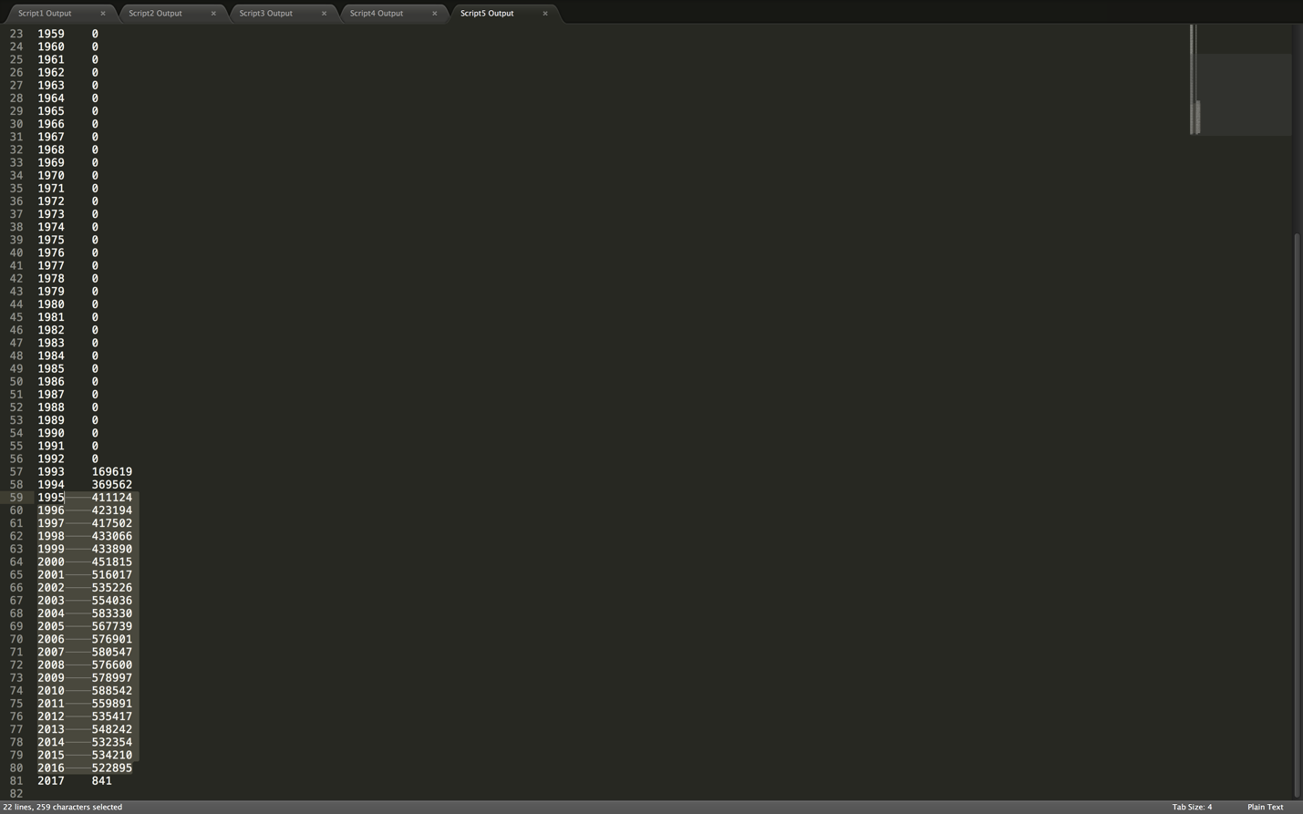

This MR Script is used to answer the below questions:

* What was the total enrollment last year at UB?

The total enrollment at UB was 522895 (includes summer, fall, winter and spring)

* What is the total enrollment at UB every year?

The data that we have has shown that the enrollment in UB every year is as follows (from 1993)

1995 411124

1996 423194

1997 417502

1998 433066

1999 433890

2000 451815

2001 516017

2002 535226

2003 554036

2004 583330

2005 567739

2006 576901

2007 580547

2008 576600

2009 578997

2010 588542

2011 559891

2012 535417

2013 548242

2014 532354

2015 534210

2016 522895

* Has the enrollment at UB increased/decreased over the last decade and by how much?

A decade ago, in 2006, enrollment was 576901 and now in 2016, it is 522895. We can see that enrollment has actually dropped by ~10% since 2006.